BOSS Online Banking Guide

Mobile Access – Quick Reference Guide
BOSS Online Banking is now accessible through a Mobile Banking App. To access the Online Banking app through your mobile device, follow the steps below.

Locating the BOSS mobile app in the Google Play Store and Apple App Store
- Open the Google Play Store or Apple App Store
- Browse or search for Fulton Bank.
- Click the BOSS Mobile Banking app.
- Click install App.

Logging into the BOSS Mobile App
- Click the BOSS mobile app
- The BOSS login page will be displayed
- Enter in your Company ID, User ID, and Password
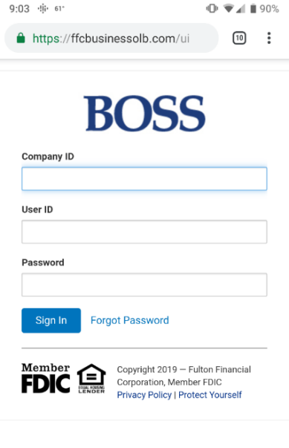

How to give BOSS Mobile access to your users
- Login to BOSS Online Banking
- Click on Administration & Settings
- Click on User Maintenance
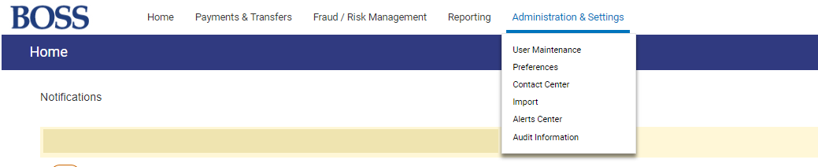
- The client user list will appear, identify the user to give mobile access. Next to that user select the drop down arrow under the Actions column and select Modify
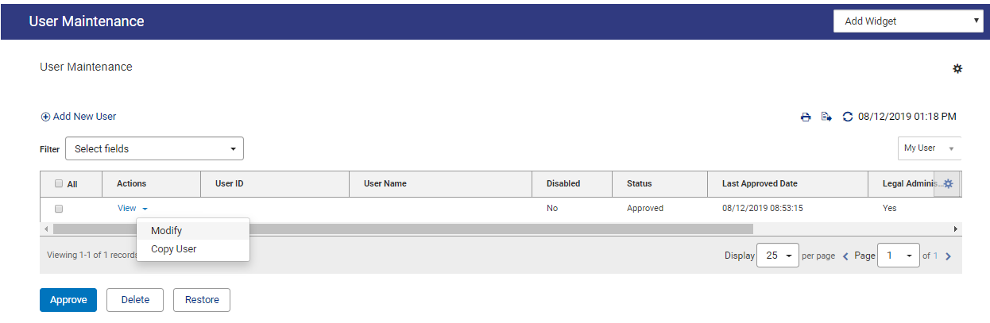
- The User Information Screen will appear. Scroll down to the Admin Settings. Under the Challenge Method field there will be a Mobile User check box option. Check the box and select Update to add Mobile access to the user.
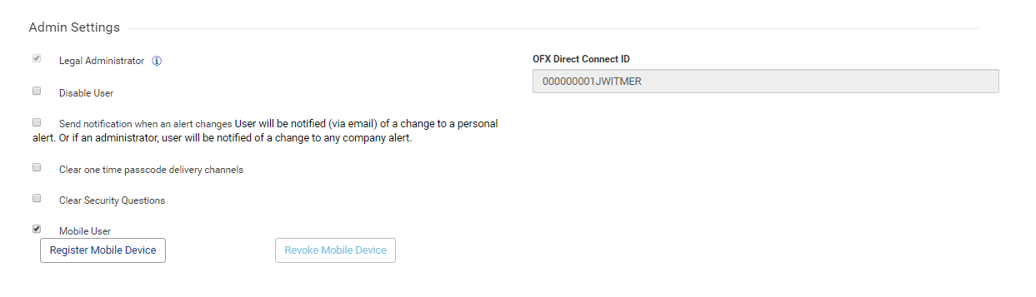

Basic navigation – Mobile App
- Once you have successfully logged into BOSS Mobile App, you will be re-directed to the Home Screen.

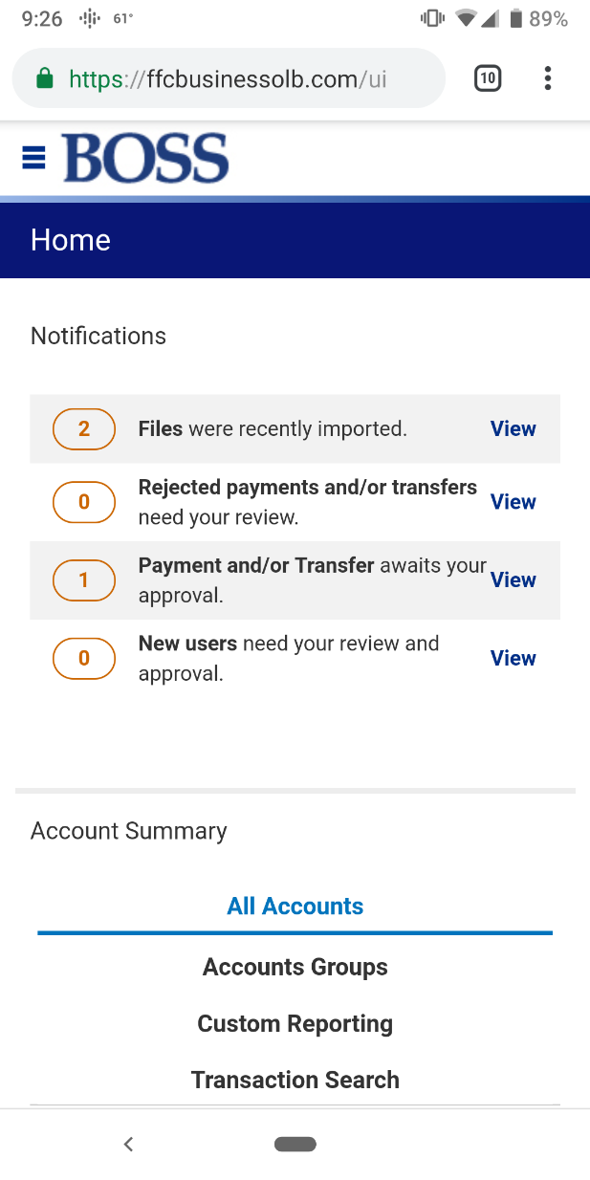

- Clicking on the Menu Bar will allow you to access all available entitlements.

- The BOSS mobile app will have the same functionality as the desktop site, providing access to:
  - Payments & Transfers
  - Fraud / Risk Management
  - Reporting
  - Administration & Settings

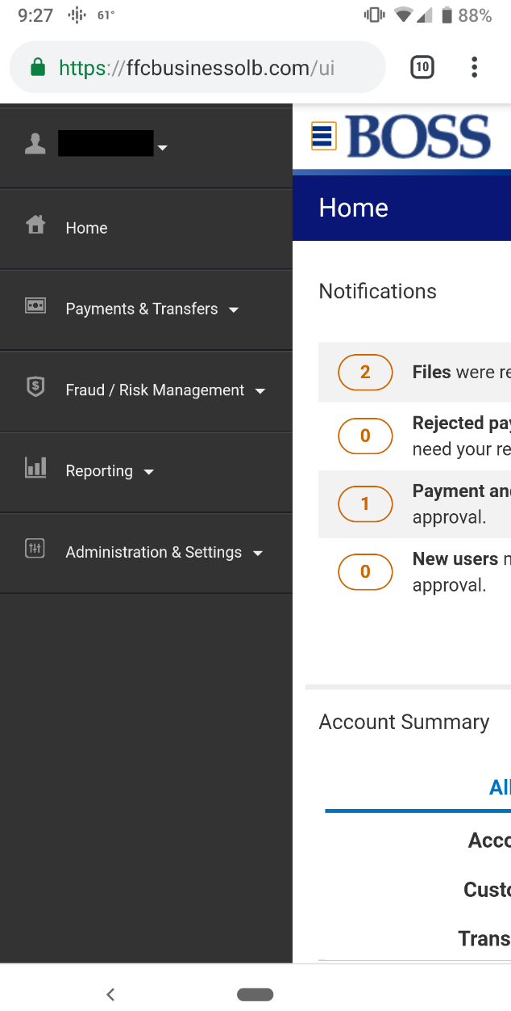

- The Account Summary view is located on the Home Screen. The Account Summary will display an overview of all active BOSS accounts.
- Expand the account menu to view current balances and account details

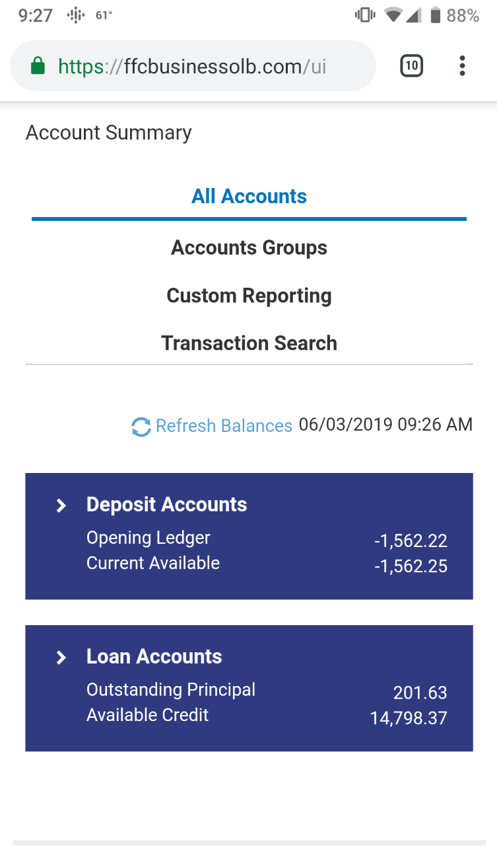

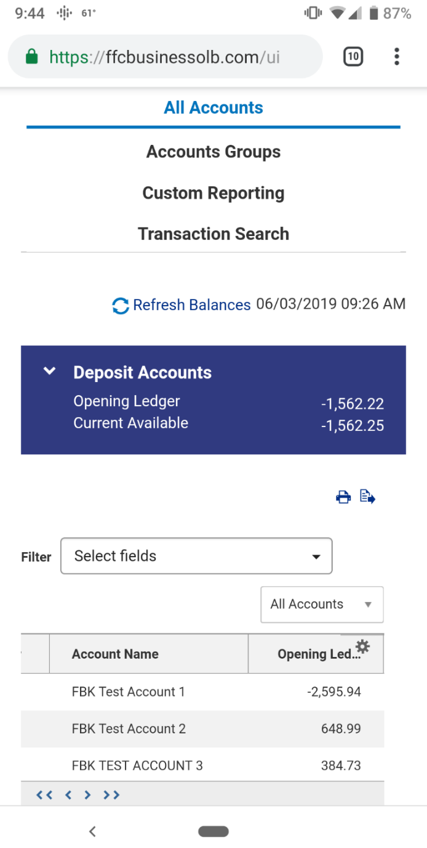
- Scrolling left and right will provide you additional details regarding your account summary

For technical support regarding mobile access to BOSS Mobile App, please call E-Commerce Support at (888)654-3858, or Cash Management Support at 866-943-8739.

